DATABASE SYSTEMS Name: Anar Kuanysh
LABORATORY WORK — WEEK 2 Group: Wed 11-12
RELATIONAL MODEL & KEYS

1. Part 1:
Task 1.1: Superkey and Candidate Key Analysis
Relation A: Employee
Employee(EmpID, SSN, Email, Phone, Name, Department, Salary)

1. Superkeys

The following are examples of superkeys:
- {EmpID}
- {EmpID, Name}
- {EmpID, Department}
- {EmpID, Salary}
- {EmpID, Phone}
- {EmpID, Email}
A superkey is a set of one or more attributes that can uniquely identify an employee.

2. Candidate Keys
The candidate keys are:
- EmpID
- SSN
- Email
These attributes can uniquely identify an employee and do not contain unnecessary attributes.

3. Primary Key
I would choose EmpID as the primary key because it is simple, unique, stable, and convenient for identifying employees.

4. Phone Number
Two employees can have the same phone number. The sample data shows different phone numbers, but the business rules do not state that Phone must be unique. Therefore, Phone is not necessarily a candidate key.

Relation B: Course Registration
Registration(StudentID, CourseCode, Section, Semester, Year, Grade, Credits)

1. Minimum Attributes for the Primary Key
The minimum attributes needed for the primary key are:
(StudentID, CourseCode, Section, Semester, Year)
This is a composite primary key.

2. Why Each Attribute Is Necessary
- StudentID identifies the student.
- CourseCode identifies the course.
- Section identifies the specific section of the course.
- Semester identifies the semester in which the registration occurs.
- Year identifies the academic year.
All five attributes are necessary to uniquely identify a registration.

3. Additional Candidate Keys
Based on the given business rules, there are no additional candidate keys.
The candidate key is:
(StudentID, CourseCode, Section, Semester, Year)
The same composite key is selected as the primary key.

Task 1.2: Foreign Key Design

1. Foreign Key Relationships
- Student.AdvisorID → Professor.ProfID
AdvisorID in the Student table references ProfID in the Professor table. This means that a student's advisor is a professor.
- Course.DepartmentCode → Department.DeptCode
DepartmentCode in the Course table references DeptCode in the Department table. This means that each course belongs to a department.
- Department.ChairID → Professor.ProfID
ChairID in the Department table references ProfID in the Professor table. This means that the chair of a department is a professor.
- Enrollment.StudentID → Student.StudentID
StudentID in the Enrollment table references StudentID in the Student table. This connects each enrollment record to a student.
- Enrollment.CourseID → Course.CourseID
CourseID in the Enrollment table references CourseID in the Course table. This connects each enrollment record to a course.

Task 2.1 — Hospital Management System
The following entities are included:
- Patient — stores patient information such as PatientID, Name, Birthdate, Address, Phone and Insurance.
- Doctor — stores DoctorID, Name, Specialization, Phone and OfficeLocation.
- Department — stores DepartmentCode, Name and Location.
- Appointment — represents an appointment between a patient and a doctor and includes DateTime, Purpose and Notes.
- Prescription — represents medications prescribed by doctors to patients and includes Dosage and Instructions.
- Medication — represents the medications used in prescriptions.
- HospitalRoom — represents hospital rooms. RoomNumber is unique only within a department, so HospitalRoom is a weak entity.

Relationships
The diagram contains the following relationships:
- Patient — Appointment — Doctor
- Doctor — Department
- Doctor — Prescription
- Patient — Prescription
- Prescription — Contains — Medication
- Department — Has — HospitalRoom

Keys
- PatientID — Patient
- DoctorID — Doctor
- DepartmentCode — Department
For HospitalRoom, the identifying key is:
DepartmentCode + RoomNumber
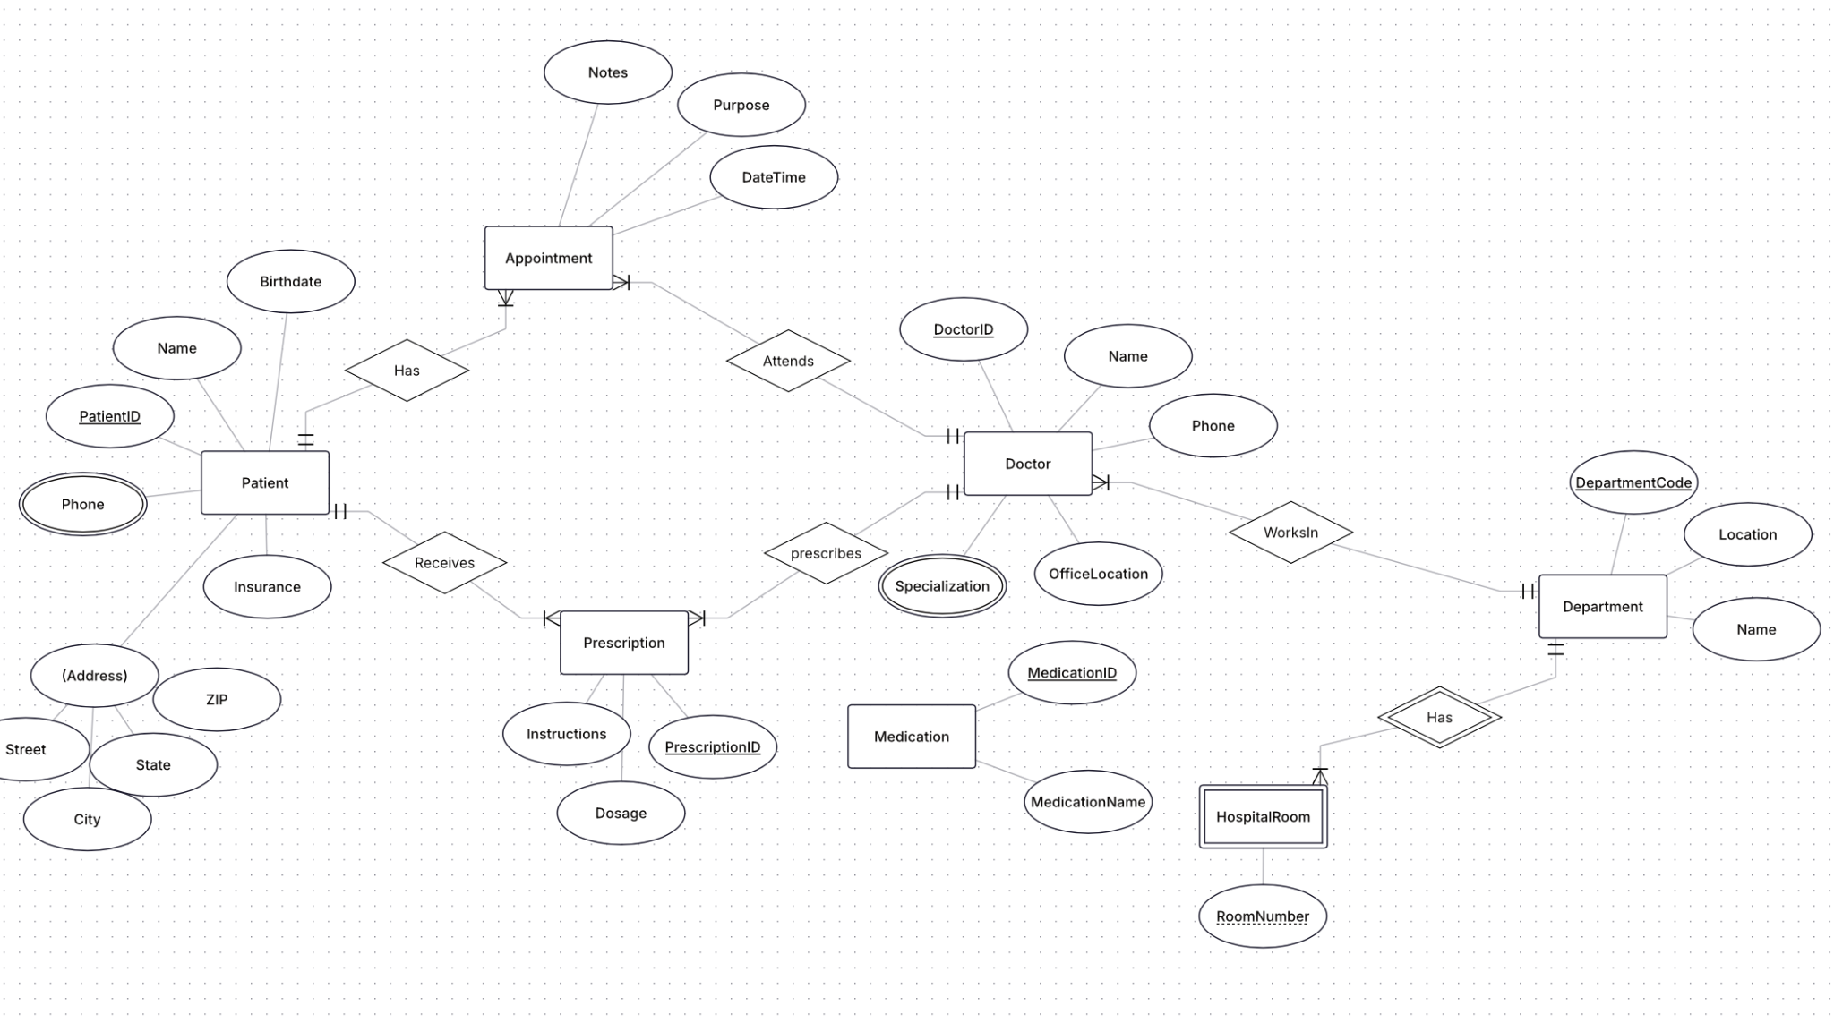

1. Introduction
The goal of this task is to design an Entity-Relationship (ER) diagram for a simplified e-commerce platform.
The system stores information about customers, orders, products, categories, vendors, order items, reviews, inventory, and shipping addresses.
The ER diagram was created using ERDPlus.

2. Entities and Attributes

Customer
- CustomerID — Primary Key

Order
- OrderID — Primary Key

Product
- ProductID — Primary Key

Category
- CategoryID — Primary Key

Vendor
- VendorID — Primary Key

OrderItem
- Quantity
- PriceAtOrder
OrderItem is modeled as a weak entity.

Review
- ReviewID — Primary Key
- Rating
- ReviewText

Inventory
- InventoryID — Primary Key
- Quantity

ShippingAddress
- AddressID — Primary Key
- Address

3. Relationships
The following relationships were included in the ER diagram:
- Customer — Places — Order
A customer can place orders.
- Category — Contains — Product
Products belong to categories.
- Vendor — Supplies — Product
Vendors supply products.
- Order — Contains — OrderItem
An order contains multiple order items.
- Product — IsFor — OrderItem
An order item is associated with a product.
- Customer — Writes — Review
Customers can write reviews.
- Product — HasReview — Review
Products can have reviews.
- Product — HasInventory — Inventory
Inventory information is tracked for products.
- Customer — HasAddress — ShippingAddress
A customer can have shipping addresses.
- Order — ShipsTo — ShippingAddress
An order is associated with a shipping address.

4. Weak Entity
The weak entity in the diagram is OrderItem.
OrderItem is dependent on an Order and a Product. It represents a particular product included in a particular order. Therefore, it does not need to be identified independently in the same way as Customer, Product, or Order.
The identifying relationships are:
- Order — Contains — OrderItem
- Product — IsFor — OrderItem
The attributes of OrderItem are:
- Quantity
- PriceAtOrder

5. Many-to-Many Relationship with Attributes
The e-commerce system allows customers to review products.
The Customer–Product association can involve many customers and many products. The review information includes attributes such as:
- Rating
- ReviewText
These attributes describe the review made by a customer for a product.

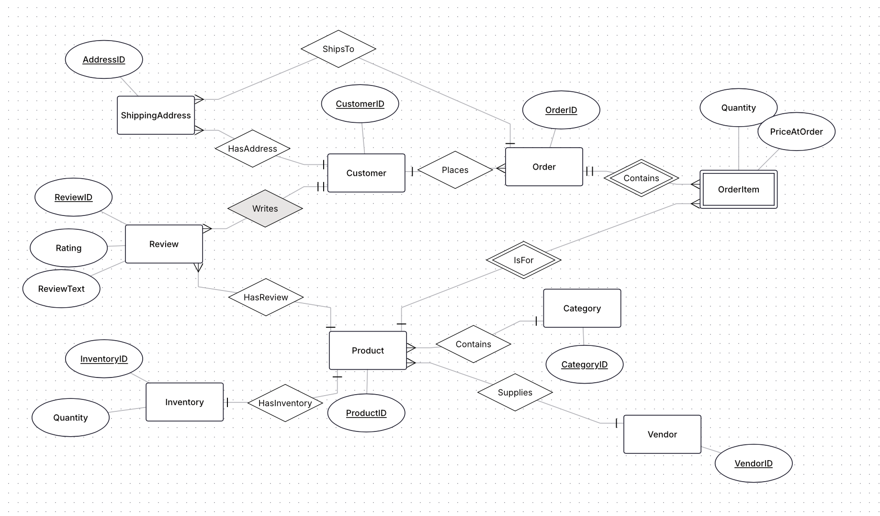

Part 4:

1. Functional Dependencies
- StudentID → StudentName
- StudentID → StudentMajor
- ProjectID → ProjectTitle
- ProjectID → ProjectType
- ProjectID → SupervisorID
- SupervisorID → SupervisorName
- SupervisorID → SupervisorDept
- {StudentID, ProjectID} → Role
- {StudentID, ProjectID} → HoursWorked
- {StudentID, ProjectID} → StartDate
- {StudentID, ProjectID} → EndDate
Transitive dependency: ProjectID → SupervisorID → SupervisorName, SupervisorDept (SupervisorName and SupervisorDept depend on ProjectID only indirectly, through SupervisorID).

2. Problems
Redundancy: StudentName and StudentMajor repeat once for every project that student works on. ProjectTitle, ProjectType, SupervisorID, SupervisorName and SupervisorDept repeat once for every student assigned to that project. SupervisorName and SupervisorDept repeat once for every project that supervisor oversees.
Update anomaly: If a student changes their major, every row containing that StudentID must be updated. If even one row is missed, the table becomes inconsistent — the same student appears with two different majors.
Insert anomaly: A new project cannot be recorded until at least one student is assigned to it, because ProjectID only appears together with a StudentID in this flat table. There is no way to store project metadata (title, type, supervisor) on its own before a student joins.
Delete anomaly: If the only student assigned to a project is removed from the table (e.g., they finish early and their row is deleted), all information about that project — title, type, supervisor — is lost along with it.

3. 1NF Check
The table has no repeating groups or multi-valued attributes — every cell holds a single atomic value, and each row represents exactly one (student, project) assignment. The table is already in 1NF; there is no violation to fix.

4. 2NF
Primary key: {StudentID, ProjectID} — a student can work on multiple projects and a project can have multiple students, so only the combination of both attributes uniquely identifies a row.
Partial dependencies (violate 2NF):
- StudentName, StudentMajor depend only on StudentID (part of the key)
- ProjectTitle, ProjectType, SupervisorID, SupervisorName, SupervisorDept depend only on ProjectID (part of the key)
- Role, HoursWorked, StartDate, EndDate depend on the full composite key — these are fine

5. 3NF
Transitive dependency: Inside the Project table from the 2NF step, ProjectID → SupervisorID → SupervisorName, SupervisorDept. SupervisorName and SupervisorDept depend on SupervisorID (a non-key attribute), not directly on ProjectID. This violates 3NF.

Task 4.2: Advanced Normalization (краткая версия)
Table: CourseSchedule(StudentID, StudentMajor, CourseID, CourseName, InstructorID, InstructorName, TimeSlot, Room, Building)

1. Primary Key
Явного столбца Section нет, поэтому ключ выводится из бизнес-правил:
- {TimeSlot, Room} → CourseID, InstructorID (один room в один timeslot = один класс)
- {CourseID, TimeSlot} → Room, InstructorID (одна секция курса = один room/instructor)
Primary Key: {StudentID, CourseID, TimeSlot}

2. Functional Dependencies
- StudentID → StudentMajor
- CourseID → CourseName
- InstructorID → InstructorName
- Room → Building
- {TimeSlot, Room} → CourseID, InstructorID
- {CourseID, TimeSlot} → Room, InstructorID

3. Is it in BCNF?
No. None of the determinants above (other than the full key) is a superkey — every FD violates BCNF, since none of their left-hand sides include StudentID.
4. BCNF Decomposition
StudentInfo(StudentID, StudentMajor)
Course(CourseID, CourseName)
Instructor(InstructorID, InstructorName)
RoomInfo(Room, Building)
Section(CourseID, TimeSlot, Room, InstructorID)
FK: CourseID → Course(CourseID)
FK: InstructorID → Instructor(InstructorID)
FK: Room → RoomInfo(Room)
Enrollment(StudentID, CourseID, TimeSlot)
FK: StudentID → StudentInfo(StudentID)
FK: {CourseID, TimeSlot} → Section(CourseID, TimeSlot)

5. Information Loss
The decomposition is lossless (each step splits on a rule X→Y, where X is common to both resulting tables) and dependency-preserving (every original FD can be checked locally within a single table, with no join required).

